1. How are inline and block elements different from each other?
Ans.: An inline element does not cause a line break and does not take a full width of a page only the space bounded by its opening and closing tag, it is basically used within other HTML elements. Examples of inline elements <a>, <em>, <img>.

A block-level element always starts on a new line and takes up the full width of a page, from left to right. A block-level element can take up one line or multiple lines and has a line break before and after the element. Example of block level <h1>,<div>,<ol>,<ul>.

2. Explain the difference between visibility:hidden and display:none?
Ans. Visibilty: hidden hides the elements but element still takes up space in the layout.
Display: none hide the element and element does not take the space of the layout and other elements can use that space.

3. Explain the clear and float properties.
Ans.: The float property is used for positioning and formatting content.
Float:left = the element floats left of the container.
Float:rigth = the elements float right of the continer
Float:rigth = the elements float right of the continer
Float:rigth = the elements float right of the continer

In float property if an element can fit in the horizontal space next to the floated elements, it will. Unless you apply the clear property to that element in the same direction as the float. Then the element will move below the floated elements.
None - the element is not moved down to clear past floats.
Left - the element is moved down to clear past left floats.
Right - the element is moved down to clear past right floats.
Both - the element is moved down to clear past both left and right floats.

4. Explain difference between absolute, relative,fixed and static.
Ans. Absolute: An element with position: absolute; is positioned relative to the nearest positioned ancestor
Relative: An element with position: relative; is positioned relative to its normal position. Setting the top, right, bottom, and left properties of a relatively-positioned element will cause it to be adjusted away from its normal position. Other content will not be adjusted to fit into any gap left by the element.
Fixed: An element with position: fixed; is positioned relative to the viewport, which means it always stays in the same place even if the page is scrolled. The top, right, bottom, and left properties are used to position the element.
Static: Static positioned elements are not affected by the top, bottom, left, and right properties. An element with position: static; is not positioned in any special way; it is always positioned according to the normal flow of the page

5. Write the HTML code to create a table in which there are 4 columns( ID , Employee Name, Designation, Department) and at least 6 rows. Also do some styling to it.
Ans:
<!DOCTYPE html>
<html>
<head>
<title>table</title>
<style type="text/css">
table, th, td{
border:2px solid black;
background-color: yellow;
}
table{
width: 100%
}
</style>
</head>
<body>
<table>
<tr>
<th>Id</th>
<th>Employee Name</th>
<th>Designation</th>
<th>Department</th>
</tr>
<tr>
<td>1001</td>
<td>Deepanjan</td>
<td>Trainee</td>
<td>FEEN</td>
</tr>
<tr>
<td>1002</td>
<td>Ayush</td>
<td>Manager</td>
<td>Dev Ops</td>
</tr>
<tr>
<td>1003</td>
<td>Riya</td>
<td>Manager</td>
<td>JVM</td>
</tr>
<tr>
<td>1004</td>
<td>Pratik</td>
<td>trainee</td>
<td>JVM</td>
</tr>
<tr>
<td>1005</td>
<td>Rishabh</td>
<td>trainee</td>
<td>FEEN</td>
</tr>
<tr>
<td>1006</td>
<td>Ruchika</td>
<td>Manager</td>
<td>FEEN</td>
</tr>
</table>
</body>
</html>

output:
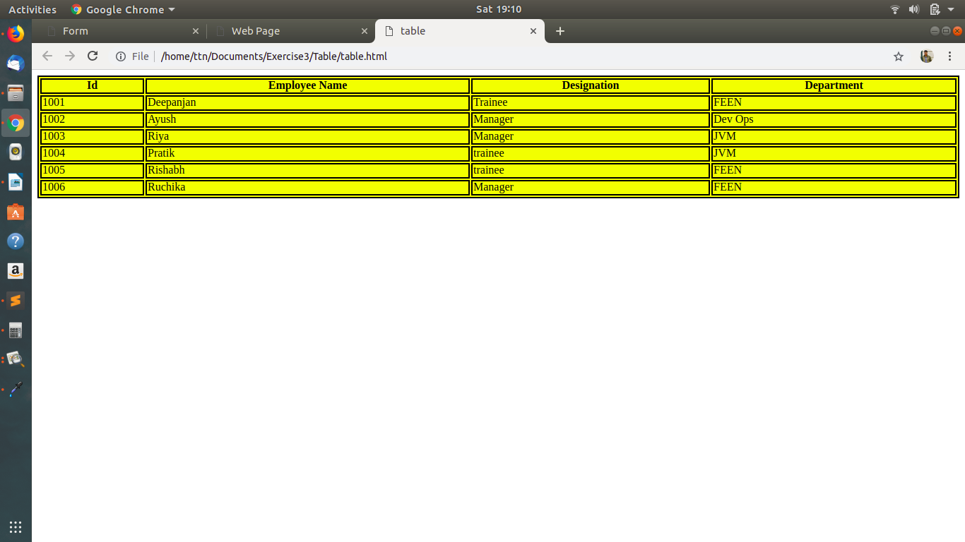

6. Why do we use meta tags?
Ans.: Metadata is data (information) about data. The <meta> tag provides metadata about the HTML document. Metadata will not be displayed on the page, but will be machine parsable. Meta elements are typically used to specify page description, keywords, author of the document, last modified, and other metadata. The metadata can be used by browsers (how to display content or reload page), search engines (keywords), or other web services.

7. Explain box model.
Ans.: The CSS box model is essentially a box that wraps around every HTML element. It consists of: margins, borders, padding, and the actual content.

8.What are the different types of CSS Selectors?
Ans.: Class (.class) : Select elements with class
Ex: <p class=”s1”>Hello World</p>
Selector= .s1{

}
Id (#id) : Select elements with id
Ex: <p id=”id1”>Hello World</p>
Selector = #id1{

}
Elements (element name) Select all element with the element name specified.
Ex: <p>Hello</p>
Selector: p{
}
* (*) : Selects all elements.

9. Define Doctype.
Ans.: The <!DOCTYPE> declaration must be the very first thing in a HTML document, before the <html> tag. The <!DOCTYPE> declaration is not an HTML tag; it is an instruction to the web browser about what version of HTML the page is written in. <!DOCTYPE html> refers tp HTML5.

10. Explain 5 HTML5 semantic tags.
Ans.: 1. <article>: Defines an article
2. <header>: Specifies a header for a document or section
3. <footer>: Defines a footer for a document or section
4.<nav> : Defines navigation links
5. <main>: Specifies the main content of a document

